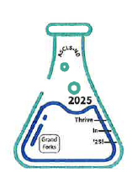
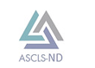
ASCLS-ND 2025 State Meeting
Theme: Thrive in 2025

Thursday May 8, 2025: Hilton Garden Inn, Grand Forks, ND
Friday May 9, 2025: UND School of Medicine and Health Sciences, Grand Forks, ND

Educational Symposium Registration Form

Join us to network with laboratory professionals from around the region. P.A.C.E. credits will be awarded for each educational session attended up to 8 total credits.

REGISTRATION

Directions:
- Registration & payment can be completed online (with minimal service charge) through the ASCLS-ND website: www.asclsnd.org OR by mail using information provided at the end of this form.
- Registrations must be postmarked by April 20, 2025. Registrations received after this date will be charged a $20 late fee.

PRICING

 | ASCLS Member | Non-  Member | Student ASCLS Member | Student  Non-Member
Single Day (5/8 OR 5/9) | $65 | $75 | $5 | $10
Both Days (5/8 AND 5/9) | $130 | $150 | $10 | $20
Vendor Social Only (5/8, 6-8pm) | $15 | $20 | $5 | $10

ACCOMODATIONS

A block of hotel rooms has been reserved for ASCLS-ND attendees at a price of $110.00 per night. Reservations must be made by March 29^{th,} 2025, to be eligible for the block price (subject to availability - we encourage you to make your reservations early).
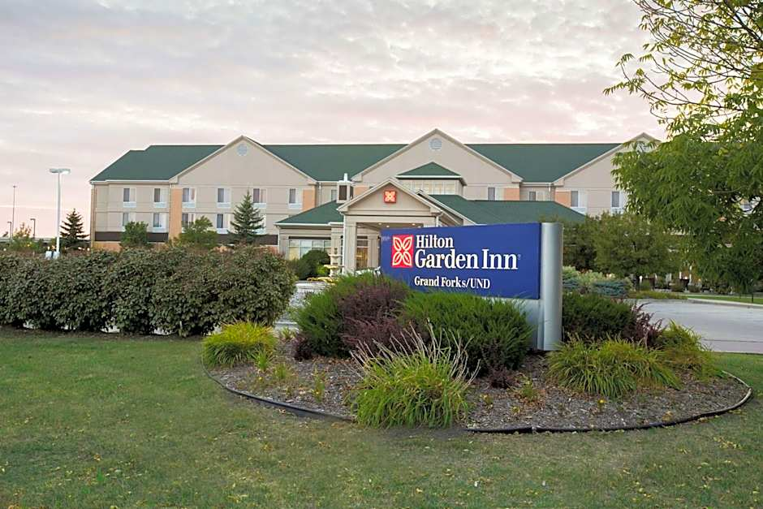

Hilton Garden Inn
4301 James Ray Drive
Grand Forks, ND 58201
Phone: 701-775-6000

SCHEDULE

Thursday, May 8th, 2025
Hilton Garden Inn
Time | Activity
10:30-11:30am | ASCLS-ND Board Meeting (for current ASCLS-ND Board Members)
Noon-12:50pm | Session 1 (Opening Keynote)
1:00-1:50pm | Session 2
2:00-2:30pm | SNACK & STRETCH BREAK
2:30-3:20pm | Session 3
3:30-4:20pm | Session 4
4:20-6:00pm | Optional UND Walking Tours
6:00-8:00pm | Vendor Social
Friday, May 9th, 2025
UND School of Medicine & Health Sciences (SMHS)
Time | Activity
8:00-8:50am | BREAKFAST & Optional SMHS Building Tours
9:00-9:50am | Session 5
10:00-10:50am | Session 6
11:00-11:50am | Session 7
Noon-12:15pm | PICK-UP LUNCH
12:15pm-1:15pm | LUNCH & ASCLS-ND Business Meeting (for all attendees)
1:30-2:20pm | Session 8 (Closing Keynote)
2:30-3:00pm | Optional UND SMHS Simulation Center Tours

---------------------------------------------------MAIL-IN REGISTRATION -------------------------------------------------------

Directions: After filling in all the information below, detach this portion of the registration form. Then, please mail both this portion of the form and a check payable to “ASCLS-ND” to:

Jessica Fry
711 N 28th St
Bismarck, ND

Your Information:

Name: ________________________________________________ Member ID #: ________________________
(required for member registration fee)
Street Address: __________________________________________

City: ______________________ State: ________________ Zip: __________________

Facility: ________________________________________________________________________________________

E-mail: _________________________________________________________________________________________
(required for registration invoice & confirmation and/or follow-up communication, if needed)

I would like to volunteer as a session moderator – YES/NO: _______
I would like to attend a UND SMHS Simulation Center Tour at 2:30pm on Friday, May 9th – YES/NO: _________

Registration Fee: ______ Late Fee (after 4/20/25): ________ Total Fee Submitted: ___________

